**Page.No.:**

**A PYTHON PROGRAM TO IMPLEMENT KNN MODEL**

**Ex.No.:**

**Date of Experiment:**

**Date of Submission:**

**AIM:-**

To implement a python program using a KNN Algorithm in an model.

**ALGORITHM:-**

Step1: Import all the other necessary libraries(numpy as np, matplotlib.pyplot as plt and sklearn.tree,pandas as pd and seaborn as sns).

Step2: Select the number K of the neighbors.

Step3: Calculate the Euclidean distance of **K number of neighbors of data points.**

Step4: Take the K nearest neighbors as per the calculated Euclidean distance.

Step5: Among these k neighbors, count the number of the data points in each category.

Step6: Assign the new data points to that category for which the number of the neighbor is maximum.

Step7: Plot the graph “X” and “y” the values tested and predicted using seaborn.scatterplot() function.

Step8: Print the confusion matrix of the model to know the accuracy of the model with support values for each class.

**IMPLEMENTATION:-**

import numpy as np

import pandas as pd

from matplotlib import pyplot as plt

from sklearn.datasets import load_breast_cancer

**Page.No.:**

from sklearn.metrics import confusion_matrix

from sklearn.neighbors import KNeighborsClassifier

from sklearn.model_selection import train_test_split

import seaborn as sns

sns.set()

breast_cancer = load_breast_cancer()

X = pd.DataFrame(breast_cancer.data, columns=breast_cancer.feature_names)

X = X[['mean area', 'mean compactness']]

y = pd.Categorical.from_codes(breast_cancer.target, breast_cancer.target_names)

y = pd.get_dummies(y, drop_first=True)

X_train, X_test, y_train, y_test = train_test_split(X, y, random_state=1)

import warnings

warnings.filterwarnings('ignore')

knn = KNeighborsClassifier(n_neighbors=5, metric='euclidean')

knn.fit(X_train, y_train)

KNeighborsClassifier(metric='euclidean')

y_pred = knn.predict(X_test)

sns.scatterplot(

x='mean area',

y='mean compactness',

hue='benign',

data=X_test.join(y_test, how='outer')

)

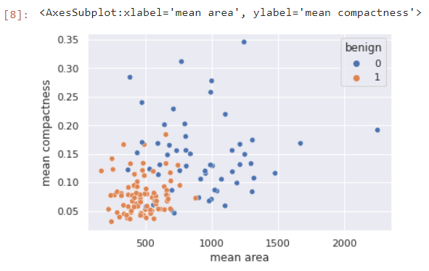

plt.scatter(

X_test['mean area'],

X_test['mean compactness'],

c=y_pred,

cmap='coolwarm',

alpha=0.7

)

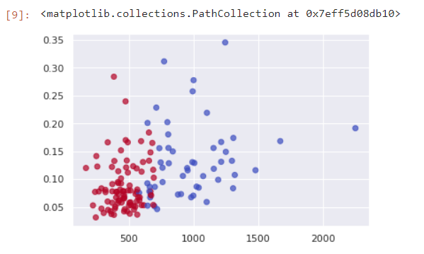

confusion_matrix(y_test, y_pred)

array([[42, 13],

[ 9, 79]])

**RESULT:-**

Thus the python program to implement KNN model has been successfully implemented and the results have been verified and analyzed.